Steps to Make the Gilded Bat Puppet

This puppet was inspired by the artist Edward Gorey’s picture book, The Gilded Bat, about a ballerina whose most famous role was as a bat with glittery gold wings. Edward Gorey’s art is weird and scary in a funny way – perfect for celebrating the Halloween season.

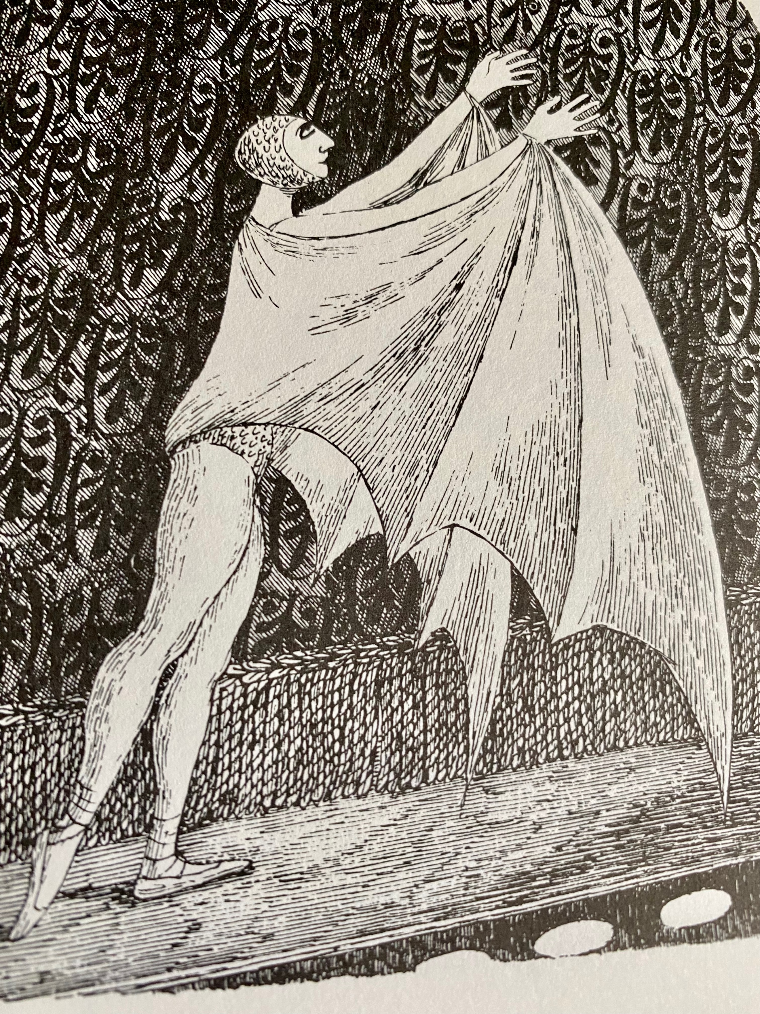
Illustration from Edward Gorey’s The Gilded Bat

Step One: Color the puppet pieces any way you like. There are two different bodies to choose from.
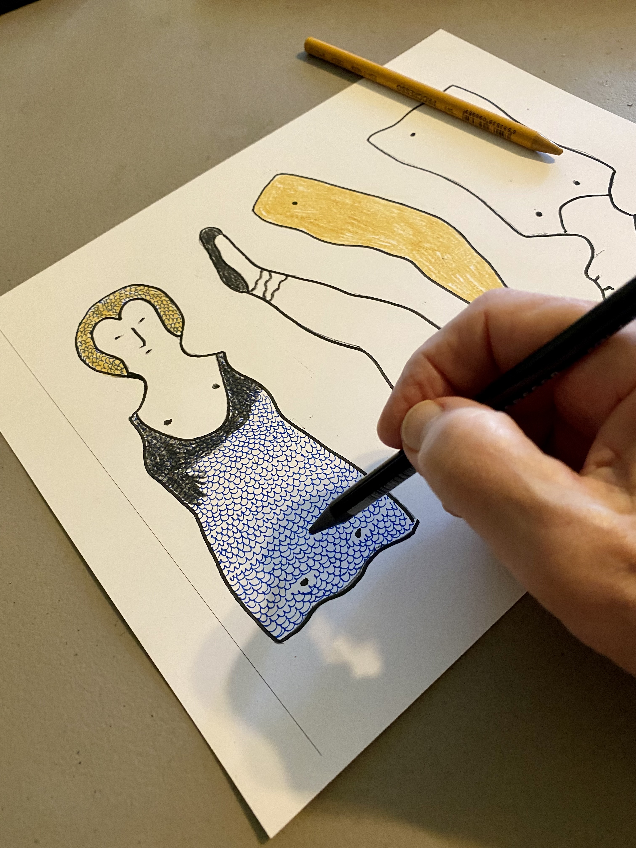

Step Two: Cut out the pieces.

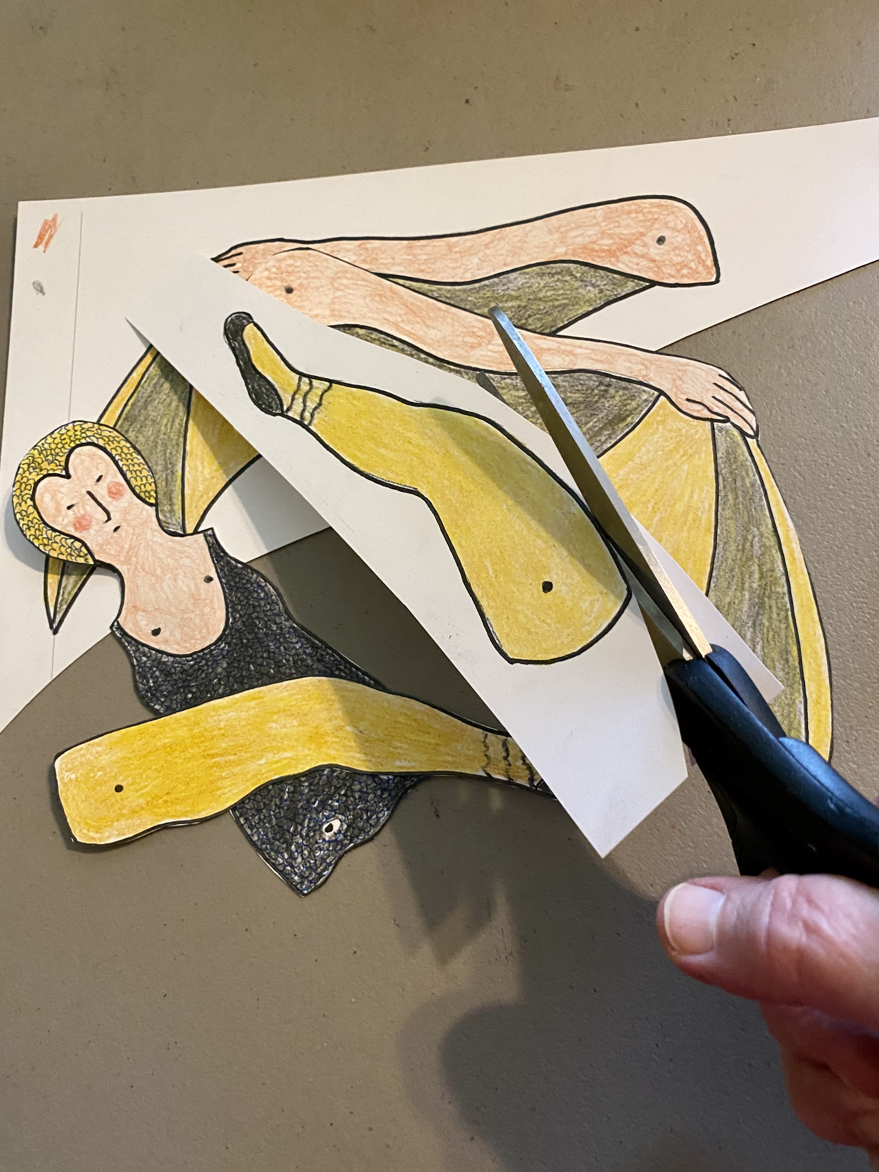

Note: Holes for the brads have been pre-punched for ease of assembly.

Step Three: Assemble the pieces, lining up the holes. Secure the pieces with the star brads.

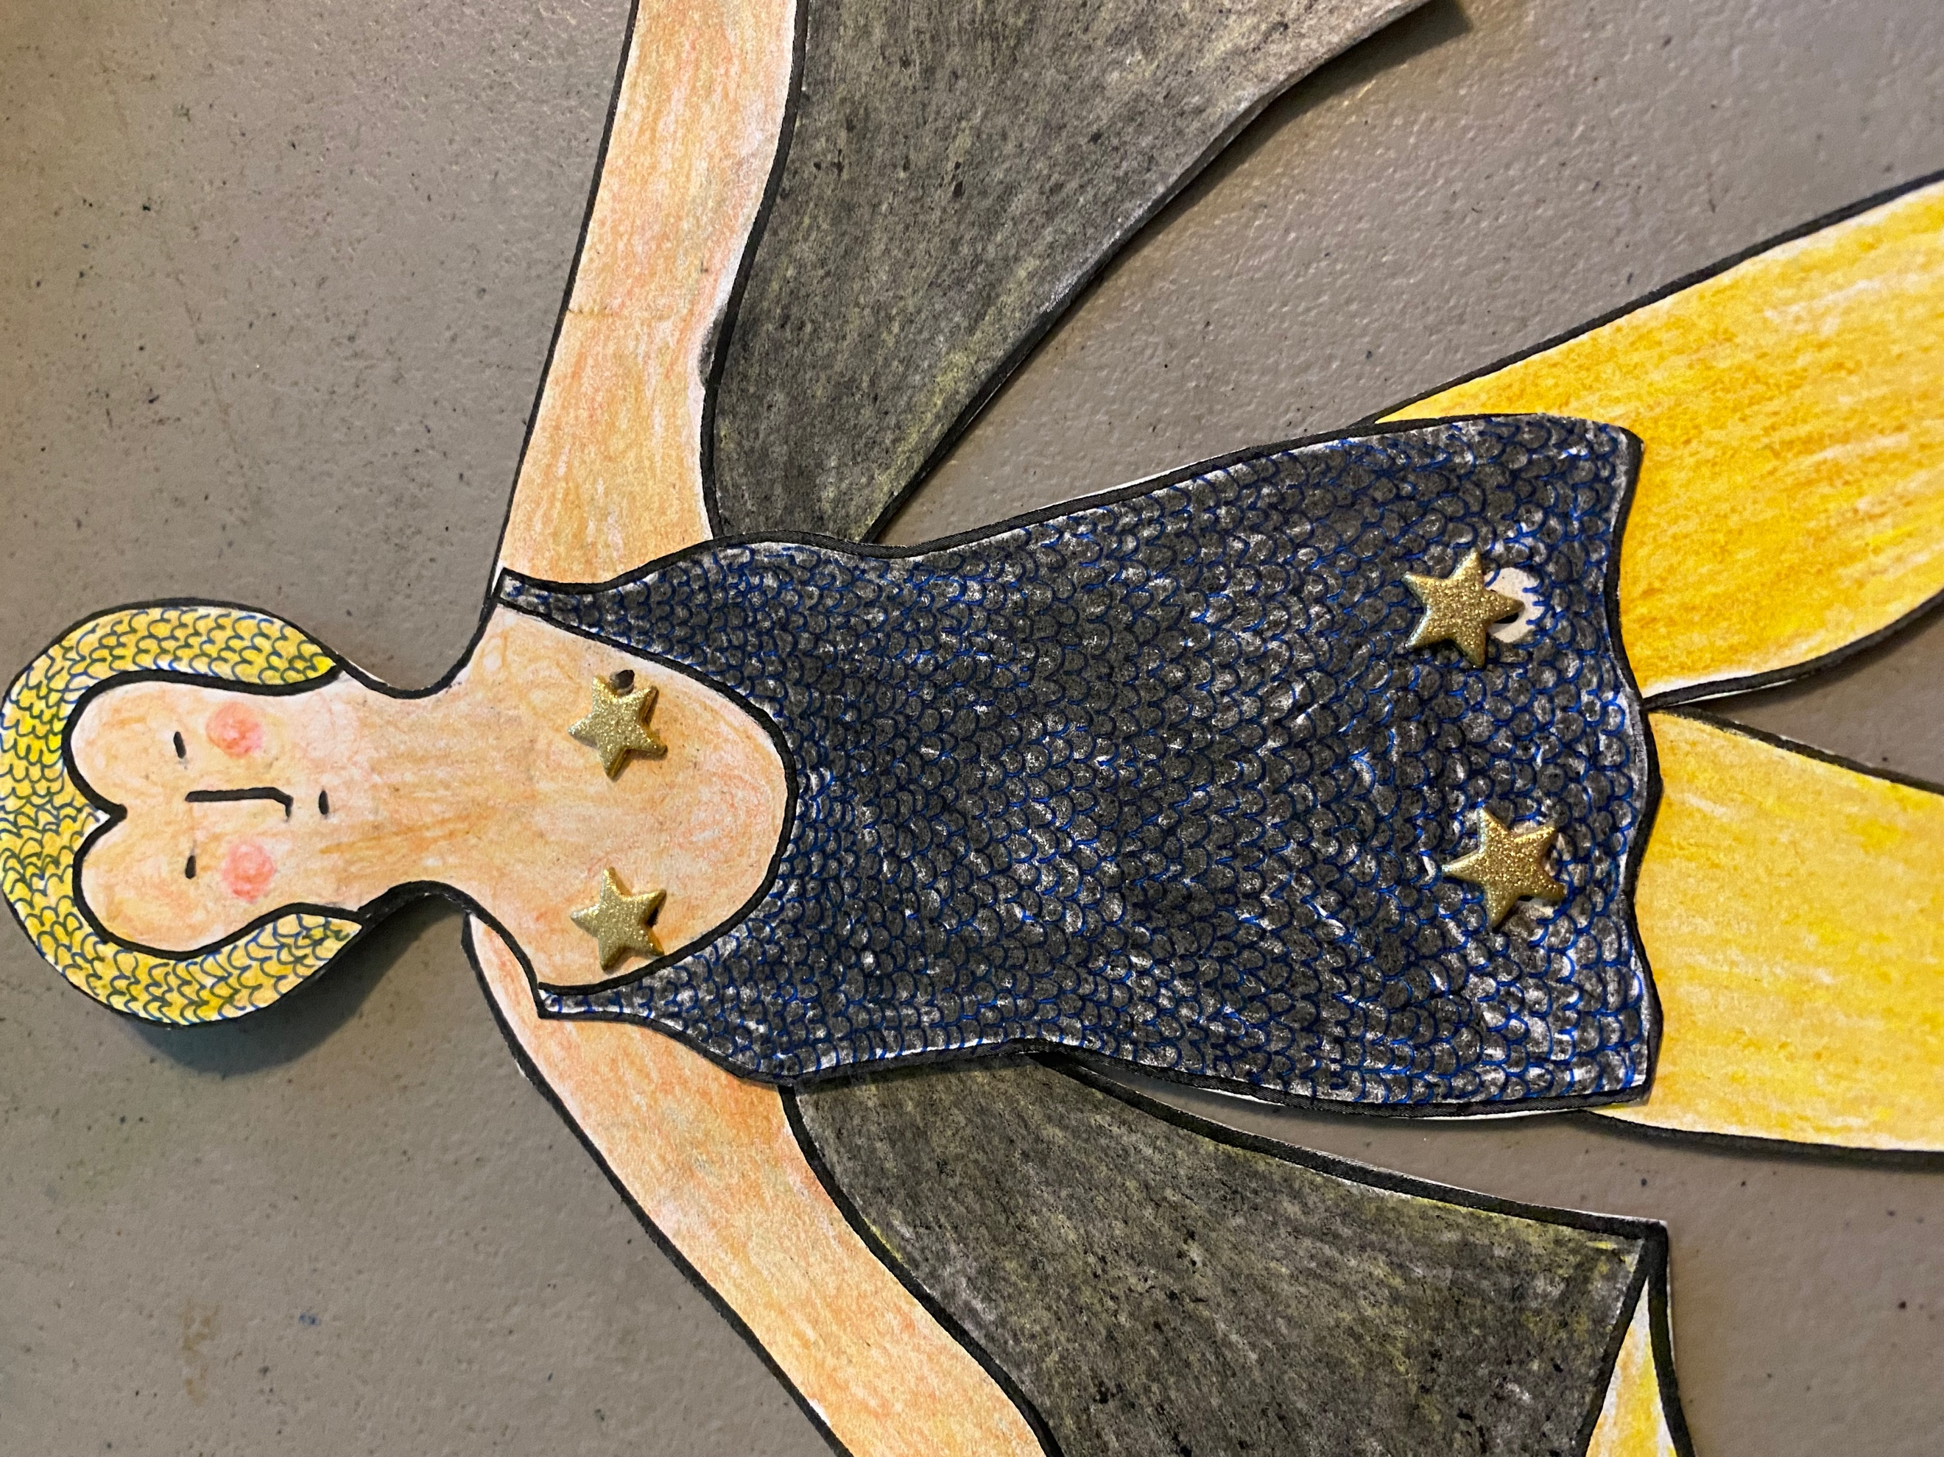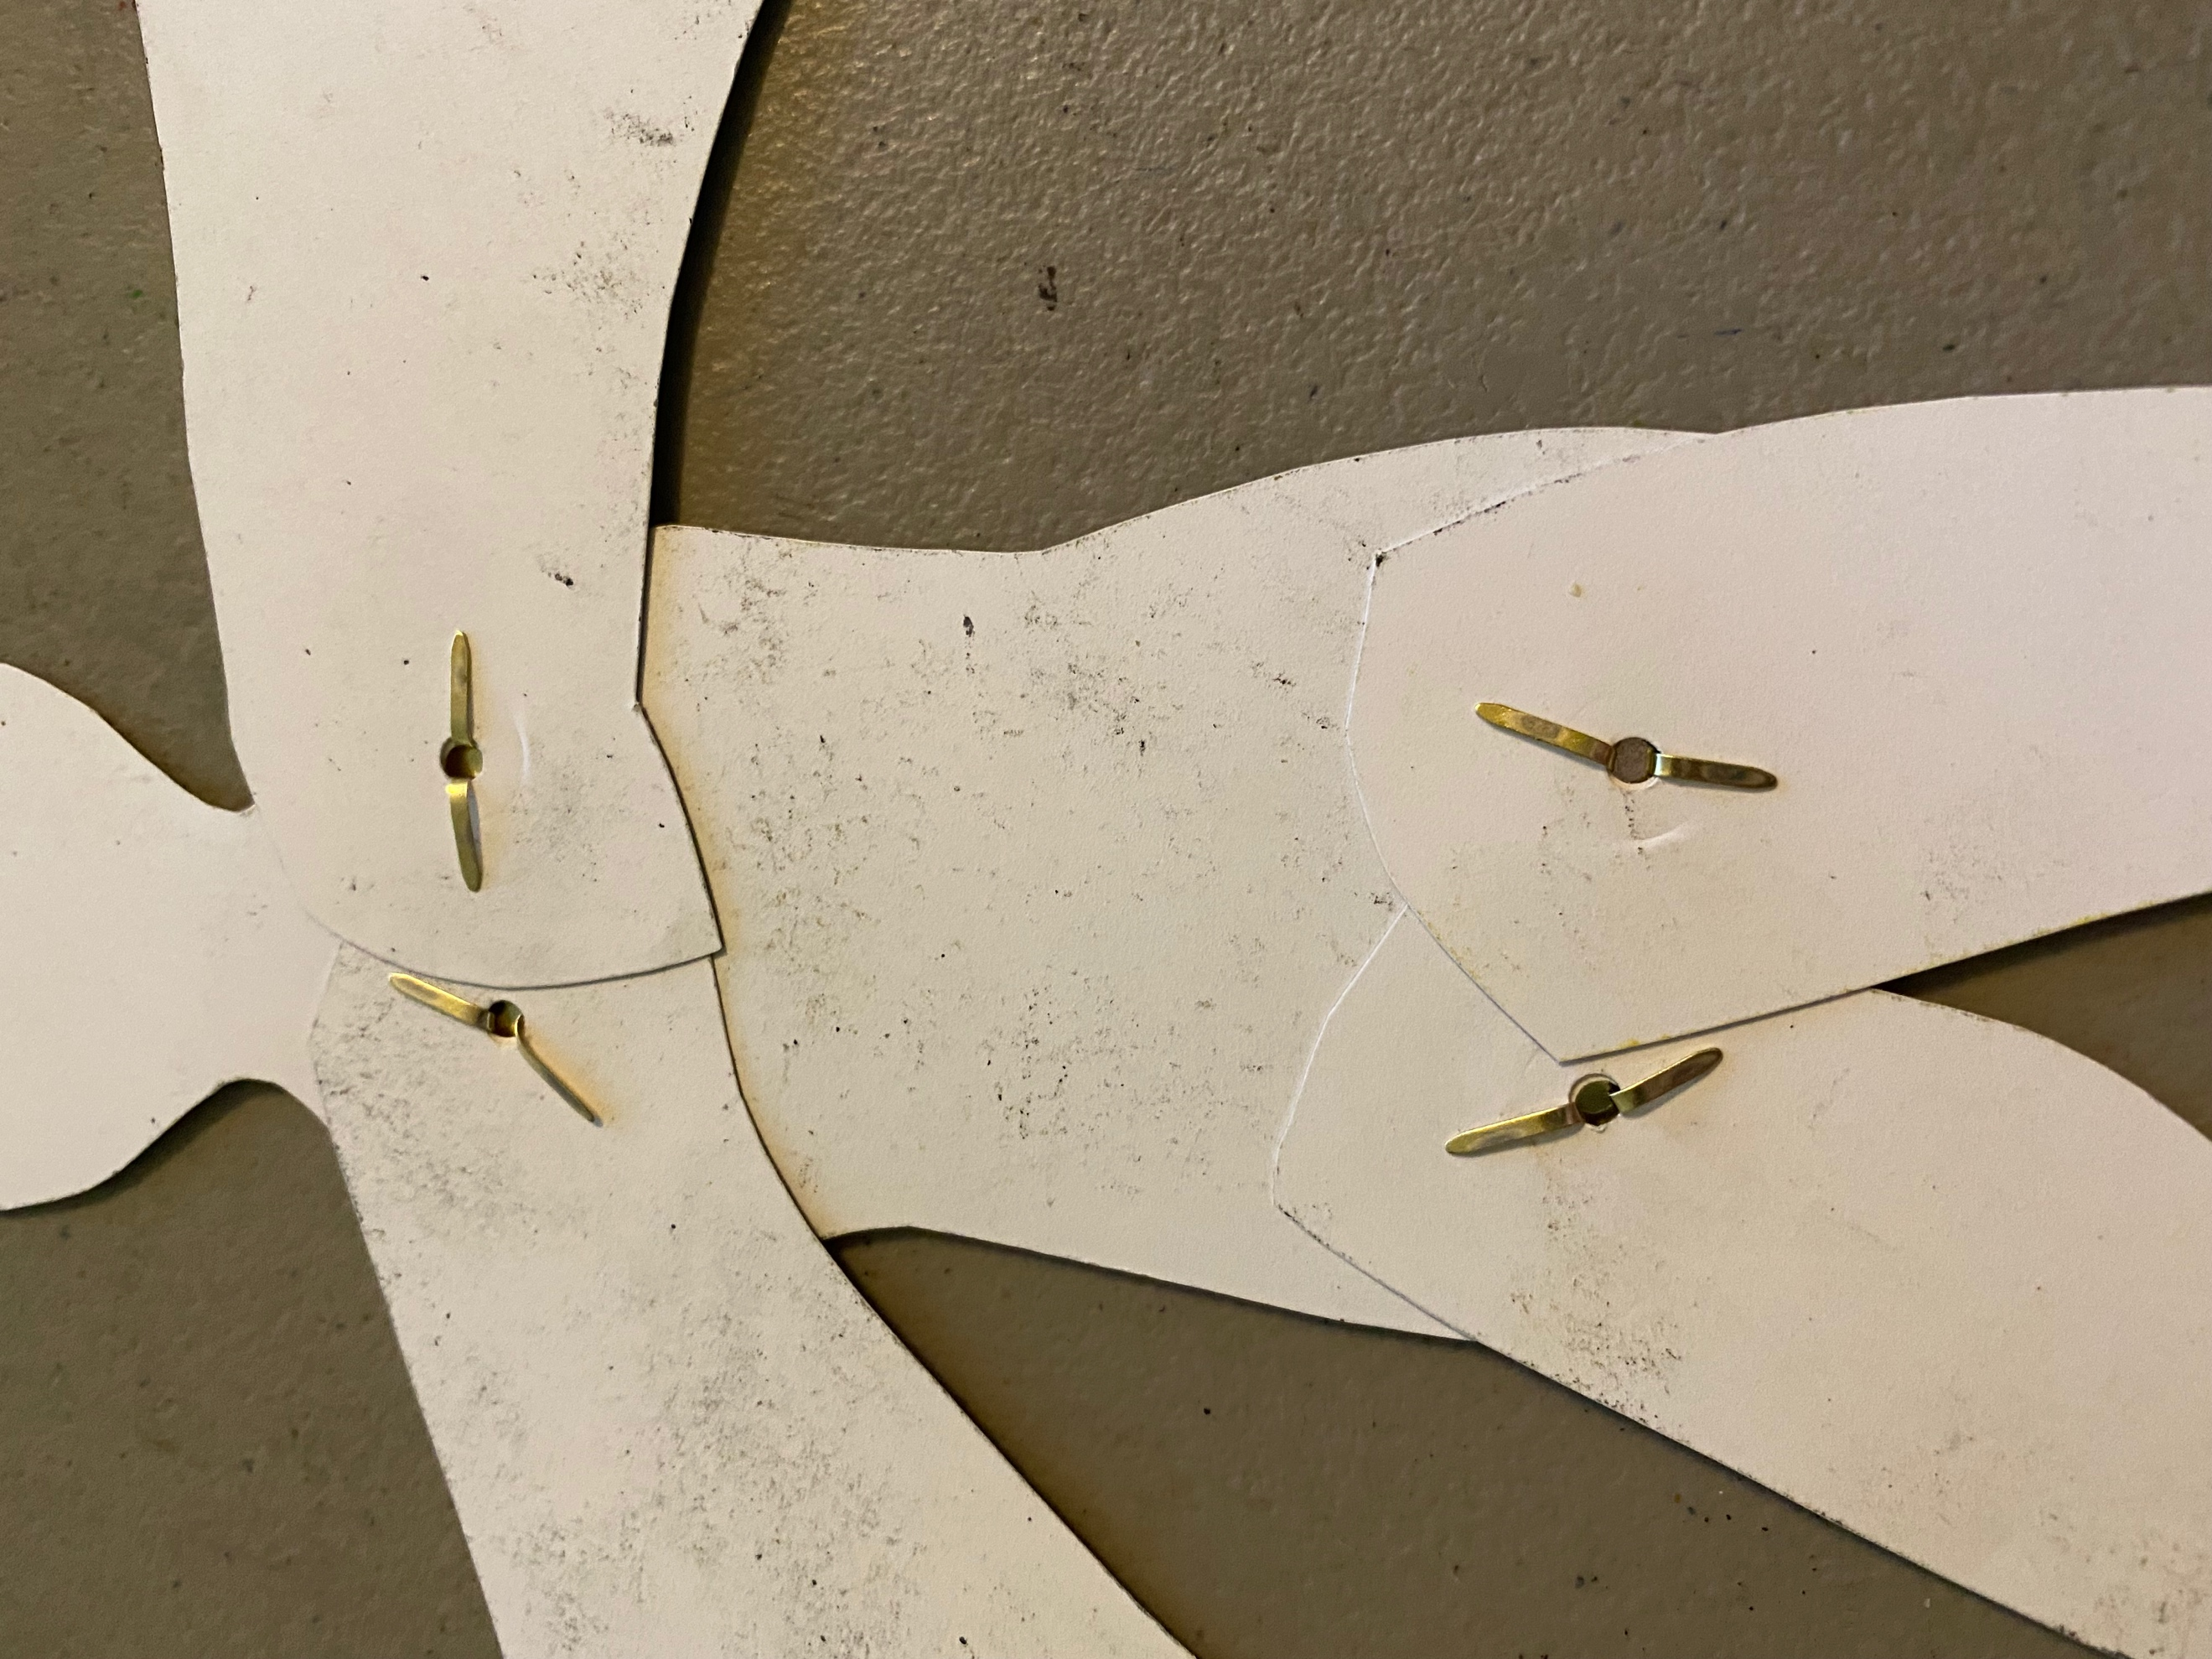

Step Four: Glue or tape a craft stick to the back of each wing.

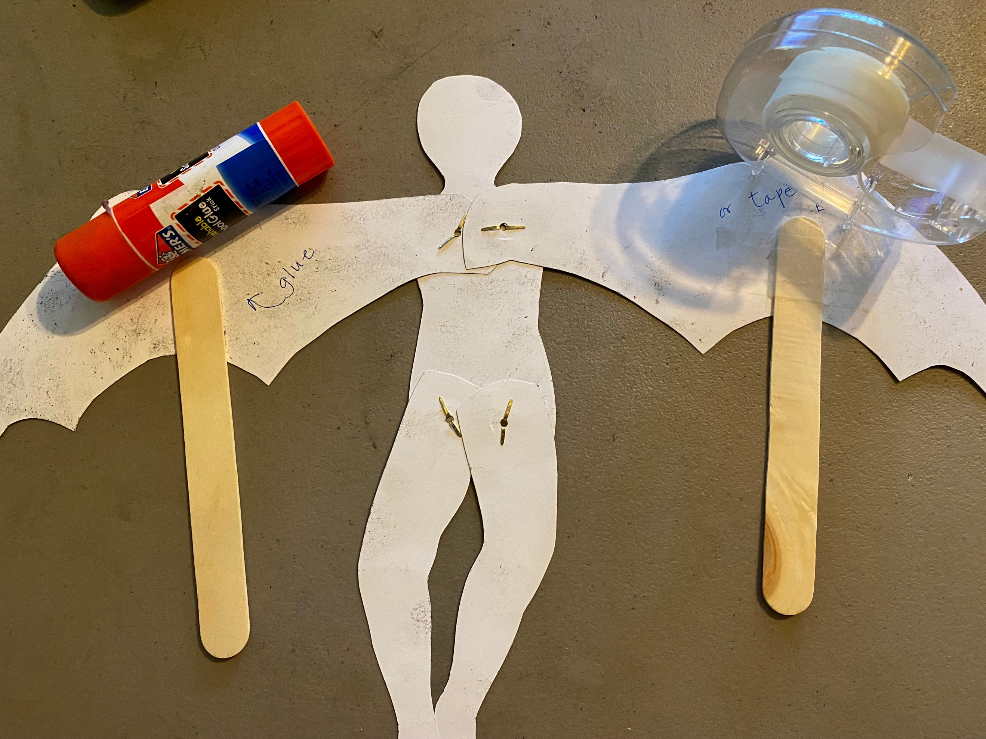

Step Five: Use the sticks to make the puppet move. You can also change the position of the legs however you like.

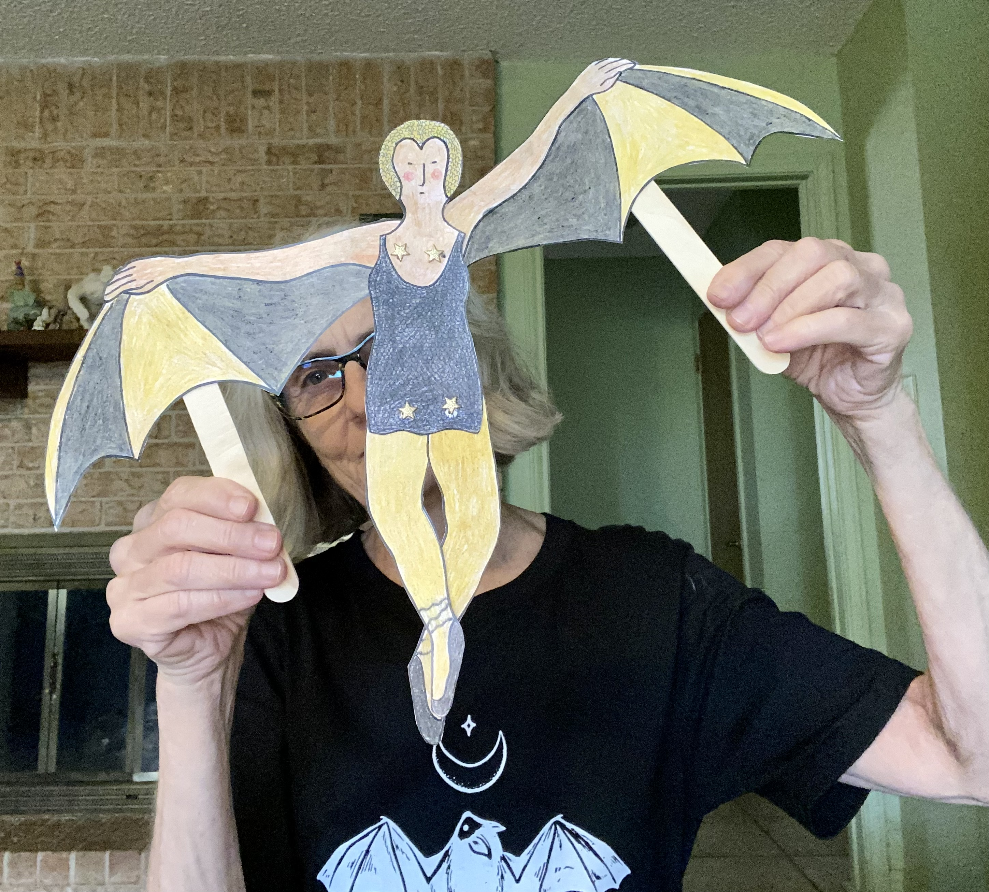 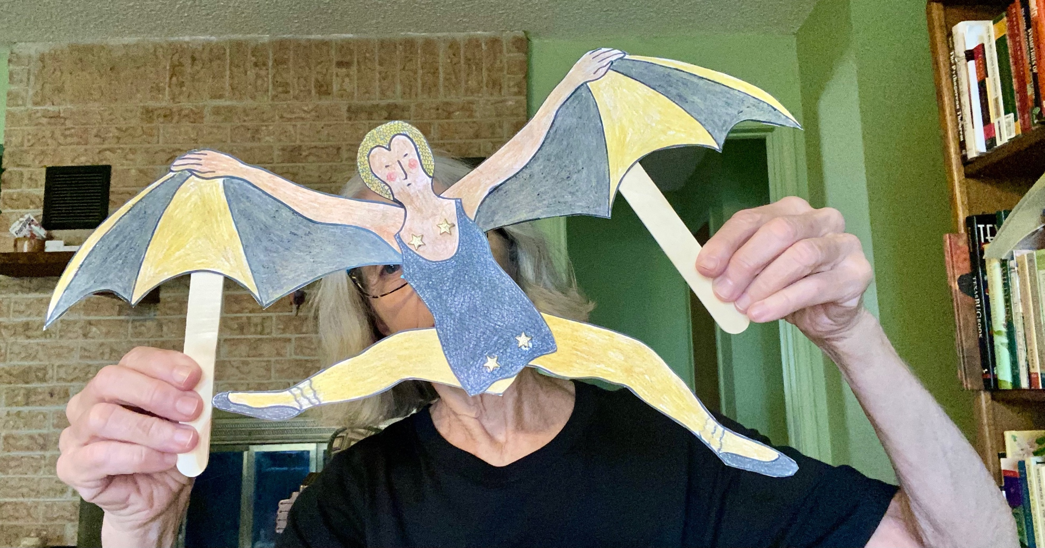Step

Six: Perform your own Gilded Bat skit!

If you print up your own templates, be sure to use cardstock.

